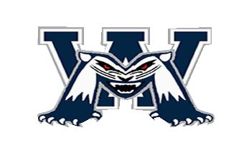
West Millbrook Middle School Loyalty Programs
WMMS PTA participates in loyalty programs at Harris Teeter, Kroger, Lowes Foods, and Amazon Smile. These programs give back a portion of your purchases directly to WMMS. You can link your cards to more than one school. Write each card number below & include all digits.
Parent Last Name: _____________________________________________________________
Harris Teeter: __________________________ OR phone # ____________________________
Lowes Foods: __________________________
Kroger requires customers to link their own cards in-store or on the Kroger web site.

smile.amazon.com - Select “PTA North Carolina Congress West Millbrook Middle School”.
Return this completed form to your student’s homeroom teacher or the main office. westmillbrookpta@gmail.com Facebook & Twitter: @wmmspta
THANK YOU FOR YOUR SUPPORT
